ELEN303 – Project

By

Sally Tabbal A2210239

Mario Makhlouta A2220007

Presented to

Dr. Nayla Greige

Circuits Lab

Faculty of Engineering

University of Balamand

May 10, 2024

**Introduction:**

Temperature transducers, also known as temperature sensors, are essential devices used to measure temperature and convert it into electrical signals. In this project, we aim to design an operational amplifier (op-amp) circuit that converts the output of a temperature transducer, covering a temperature range from -20°C to 120°C, into a voltage range of 0V to 3V. This conversion allows for standardized voltage representation of temperature data, facilitating compatibility with electronic systems.

Utilizing op-amp circuits for their precision and versatility, alongside a standard 2-Volt battery for biasing, we seek to demonstrate how temperature sensor outputs can be efficiently converted into usable voltage signals. This report outlines the design process, calculations, and implementation details, providing insights into the practical application of temperature sensing and signal conditioning in various industries.

**Objectives:**

* Design an OP AMP circuit to convert the transducer output for temperatures ranging from −20 C to 120 C to a ranging of 0 V to 3 V, respectively.
* Use a standard 2-V battery as the reference source for the required bias.
* In the following graph, the corresponding output voltages for temperatures **-20** and **120** are respectively **2.1 V** and **0.42 V.**
* The main purpose is then to provide an OP AMP circuit to convert the output voltages from the range (**0.42 V to 2.1 V)** to the range (**0 V to 3 V)**.

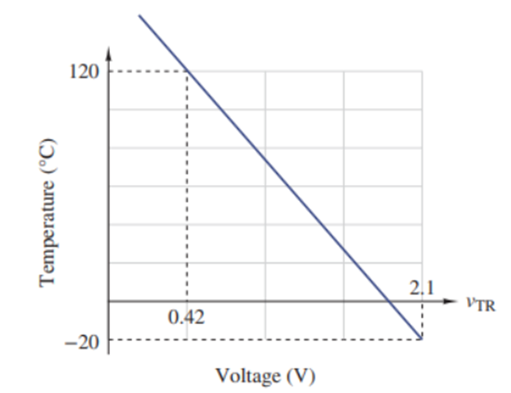

**Discussion:**

To convert the range (0.42 V to 2.1 V) to the range (0 V to 3 V):

* **First,** we should subtract 0.42 V from the transducer voltage output to obtain the range (0.42 - 0.42 to 2.1 - 0.42) which is (0 to 1.68).
* This step can be done using a **subtractor op-amp**.
* **Second,** we want to multiply the new range (0 to 1.68) by some gain to obtain the range (0 to 3).

The gain k = $\frac{desired output}{desired input}$ = $\frac{3-0}{1.68-0}$ = $\frac{3}{1.68}$ = 1.785714285714286

Then, **Vout = k * Vin.**

* This step can be done using a non-inverting op-amp.

Suppose **Vtrans** is the output voltage of the transducer and **Vfinal** is the final output of the circuit.

**Note:** We have an equation like: **Vfinal = (Vtrans – 0.42) * k**

Subtracting

Non-inverting

1. **Differential op-amp (subtractor):**

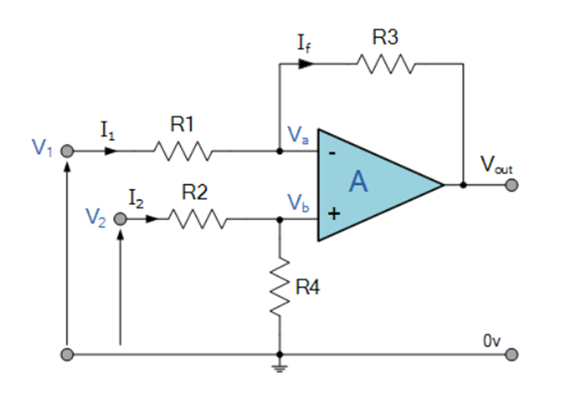

Vtrans

After applying superposition, we obtain the **general formula for voltage output:**

***Vout*** = -V1 ( $\frac{R3}{R1}$) + Vtrans ( $\frac{R4}{R2+R4}$)( $\frac{R1+R3}{R1}$)

**The desired output voltage is:**

***Vout*** = Vtrans – 0.42

By identification between the 2 formulas:

Vtrans ( $\frac{R4}{R2+R4}$)( $\frac{R1+R3}{R1}$) - V1 ( $\frac{R3}{R1}$) **=** Vtrans – 0.42

We could have simply chosen to set the coefficients of Vtrans and V1 to ‘1' and have all equal resistors R1=R2=R3=R4:

Vtrans – V1 = Vtrans – 0.42 *and simply set V1 = 0.42*

* But in order to use a standard **2-V battery** as the reference source for the required bias,

we set V1 = 2V, so the equation becomes:

Vtrans **( $\frac{R4}{R2+R4}$)( $\frac{R1+R3}{R1}$)** - 2 * ( $\frac{R3}{R1}$) = Vtrans **\*1** – 0.42

Now by identification:

( $\frac{R4}{R2+R4}$)( $\frac{R1+R3}{R1}$) = 1

2 * ( $\frac{R3}{R1}$) = 0.42 🡪 **( ) = 0.21**

We chose the corresponding resistors that satisfy these equations:

**R1 = R4 = 100 kΩ** **and**  **R2 = R3 = 21 kΩ**

1. **Non-inverting op-amp:**

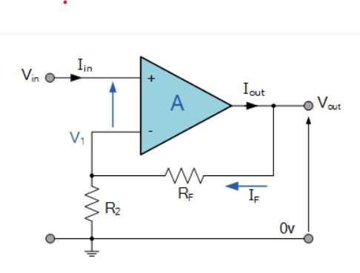

R6

R5

Now, the Vout of the subtractor op-amp will be the input voltage of the non-inverting op-amp.

As we calculated, **k = 1.785714285714286**

Since the gain for the non-inverting op-amp is given by **k=** ( $\frac{R6+R5}{R6}$)

Then, ( $1+\frac{R5}{R6}$) = 1.785714285714286

We tried to choose two values of R6 and R5 to satisfy this equation and based on the resistors available in our lab:

**R5 = 26 kΩ**

**R6 = 33 kΩ**

**Final circuit design (Multisim):**

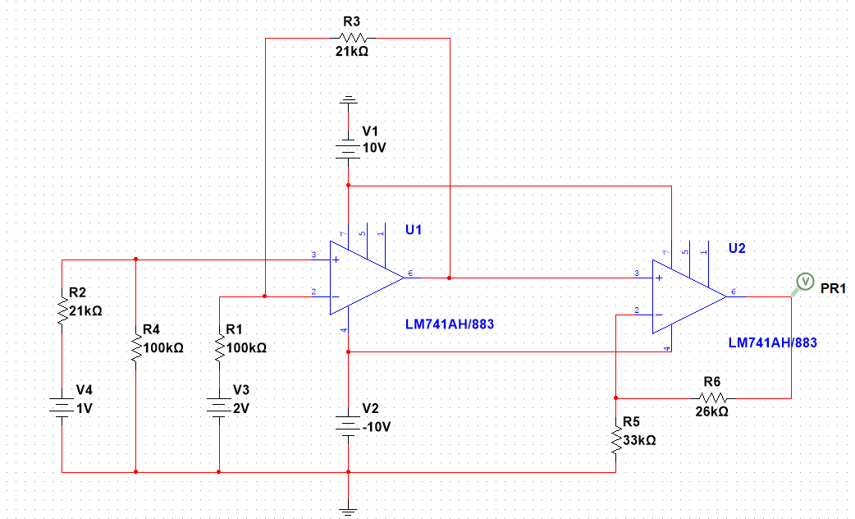

**Final voltage output graph:**

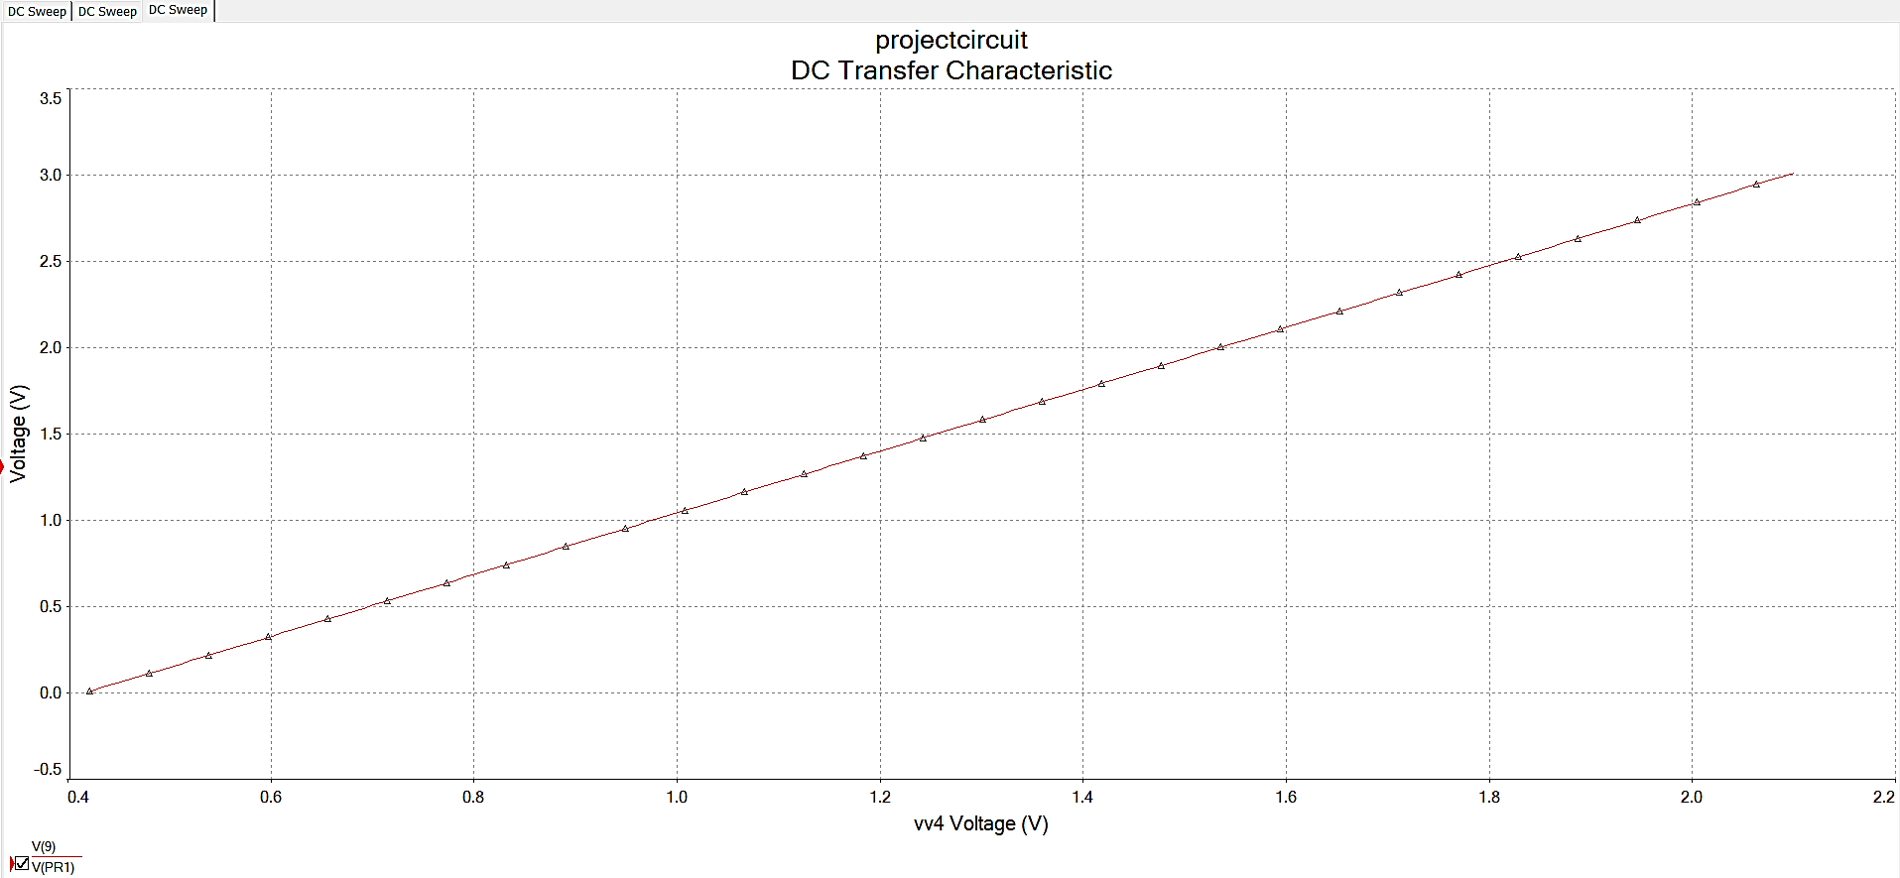

**Circuit (in Lab):**

**Conclusion:**

We observe that for the input voltage values ranging from **0.42 V to 2.1 V (x-axis),** we obtained the desired output voltage range which is from **0 V to 3 V (y-axis).**

In summary, the op-amp circuit successfully converts temperature changes into a usable voltage signal. Multisim simulation verified its functionality. This project highlights op-amp circuits' practical role in sensor interfacing, with potential for further refinement.